SUPPLEMENTARY MATERIAL

Tracking response to neoadjuvant systemic therapy through circulating tumor DNA analysis in breast cancer

Marra, Kim, et al

Table of Contents

Supplementary Table S1

Supplementary Figures S1 – S8

Supplementary Table S1. Detection of ctDNA in baseline plasma by pathologic complete response (pCR) and breast cancer subtype.

 |  | Baseline ctDNA detection
Breast cancer subtype | pCR | No (n=3) | Yes (n=15) | Total (n=18)
HR-positive/HER2-negative | No | 2 (100.0%) | 5 (83.3%) | 7 (87.5%)
 | Yes | 0 (0.0%) | 1 (16.7%) | 1 (12.5%)
HER2-positive | No | 0 (0.0%) | 3 (60.0%) | 3 (50.0%)
 | Yes | 1 (100.0%) | 2 (40.0%) | 3 (50.0%)
Triple-negative | No | 0 | 2 (50.0%) | 2 (50.0%)
 | Yes | 0 | 2 (50.0%) | 2 (50.0%)

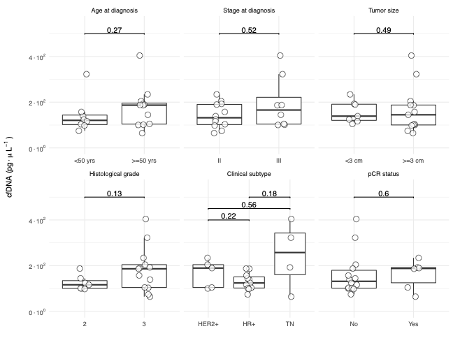
Supplementary Figure S1: Circulating cell-free DNA (cfDNA) concentration at baseline. Box plots showing the association between cfDNA concentration at baseline with clinical and pathological variables of breast cancer patients. In all panels, the boxes show the median and interquartile range. The whiskers extend to the full range of the data points excluding outliers. In all panels, the p-values were calculated using the Wilcoxon rank sum test. All tests were two-sided. HR+, hormone receptor-positive; TN, triple-negative; yrs, years.

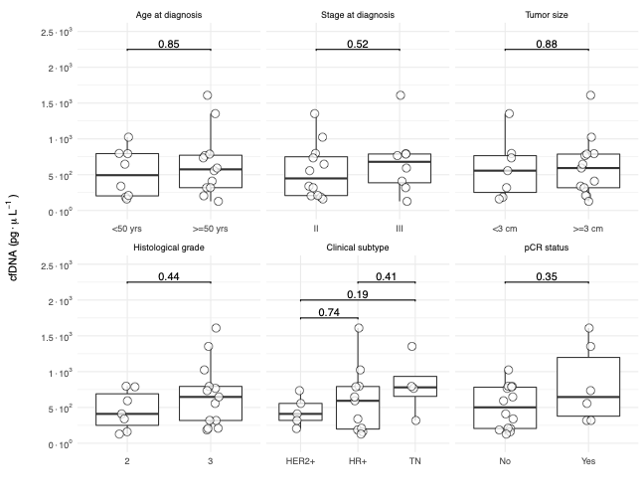
Supplementary Figure S2: Circulating cell-free DNA (cfDNA) concentration on-treatment. Box plots showing the association between cfDNA concentration on-treatment with clinical and pathologic variables of breast cancers. In all panels, the boxes show the median and interquartile range. The whiskers extend to the full range of the data points excluding outliers. In all panels, the p-values were calculated using the Wilcoxon rank sum test. All tests were two-sided. HR+, hormone receptor-positive; TN, triple-negative; yrs, years.

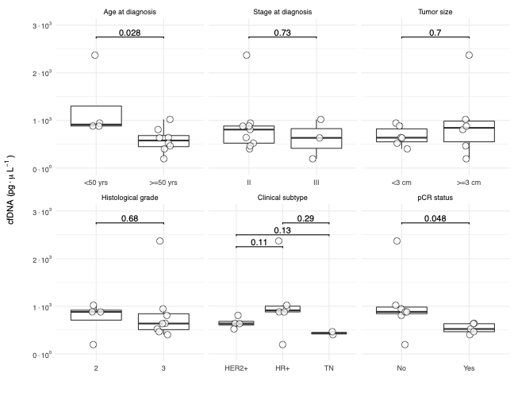
Supplementary Figure S3: Circulating cell-free DNA (cfDNA) concentration post-treatment. Box plots showing the association between cfDNA concentration post-treatment with clinical and pathologic variables of breast cancer patients. In all panels, the boxes show the median and interquartile range. The whiskers extend to the full range of the data points excluding outliers. In all panels, the p-values were calculated using the Wilcoxon rank sum test. All tests were two-sided. HR+, hormone receptor-positive; TN, triple-negative; yrs, years.

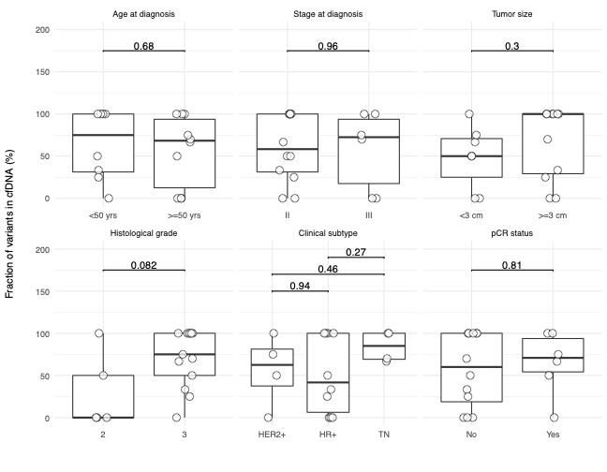
Supplementary Figure S4: Circulating tumor DNA (ctDNA) fraction at baseline. Box plots showing the association between ctDNA fraction, defined as the number of variants detected in cfDNA as a fraction of the aggregate set of variants detected in the given breast cancer patient, at baseline with clinical and pathologic variables. In all panels, the boxes show the median and interquartile range. The whiskers extend to the full range of the data points excluding outliers. In all panels, the p-values were calculated using the Wilcoxon rank sum test. All tests were two-sided. HR+, hormone receptor-positive; TN, triple-negative; yrs, years.

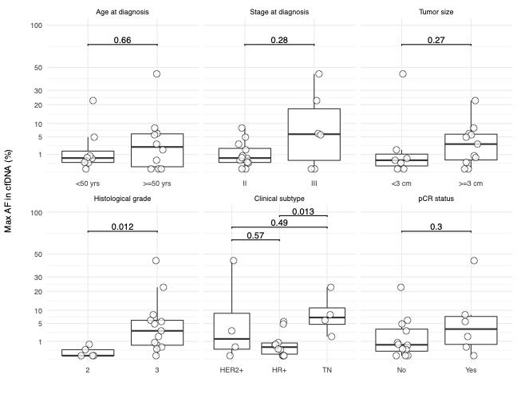
Supplementary Figure S5: Circulating tumor DNA (ctDNA) fraction at baseline. Box plots showing the association between ctDNA fraction, defined as the maximum allele fraction (AF) of any detected variant, at baseline with clinical and pathologic variables of breast cancer patients. In all panels, the boxes show the median and interquartile range. The whiskers extend to the full range of the data points excluding outliers. In all panels, the p-values were calculated using the Wilcoxon rank sum test. All tests were two-sided. HR+, hormone receptor-positive; TN, triple-negative; yrs, years.

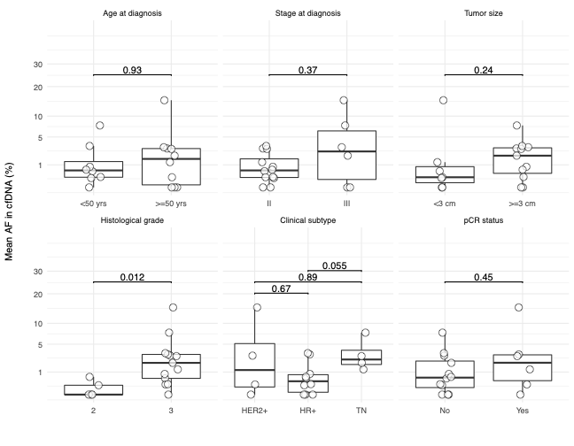
Supplementary Figure S6: Circulating tumor DNA (ctDNA) fraction at baseline. Box plots showing the association between ctDNA fraction, defined as the mean allele fraction (AF) of all detected variants, at baseline with clinical and pathologic variables of breast cancer patients. In all panels, the boxes show the median and interquartile range. The whiskers extend to the full range of the data points excluding outliers. In all panels, the p-values were calculated using the Wilcoxon rank sum test. All tests were two-sided. HR+, hormone receptor-positive; TN, triple-negative; yrs, years.

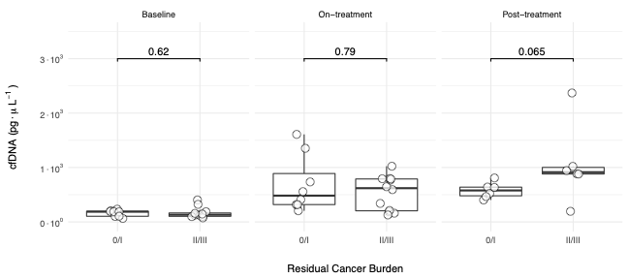
Supplementary Figure S7: Distribution of circulating cell-free DNA (cfDNA) concentration. Box plots comparing the distribution of cfDNA concentration at various time points between patients with different Residual Cancer Burden. In all panels, the boxes show the median and interquartile range. The whiskers extend to the full range of the data points excluding outliers. In all panels, the p-values were calculated using the Wilcoxon rank sum test. All tests were two-sided.

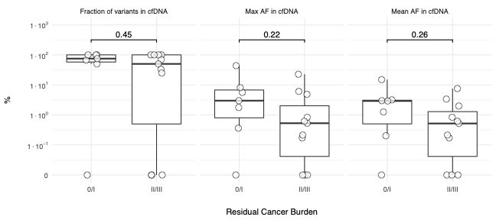
Supplementary Figure S8: Distribution of circulating tumor DNA (ctDNA). Box plots comparing the distribution of ctDNA fraction at various time points between patients with different Residual Cancer Burden. In all panels, the boxes show the median and interquartile range. The whiskers extend to the full range of the data points excluding outliers. In all panels, the p-values were calculated using the Wilcoxon rank sum test. All tests were two-sided.

